ARIFICIAL INTELLIGENCE PRACTICAL FILE

NAME = MOHD SHOHEL

ROLL NUMBER = 20201417

EXAMINATION ROLL NO. = 20020570022

COURSE = BSc(Hons) COMPUTER SCIENCE

SUBMIT TO = MR SUBODH KUMAR SIR

**Program 1: Write a prolog program to calculate the sum of two numbers.**

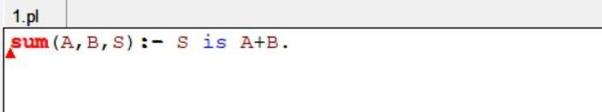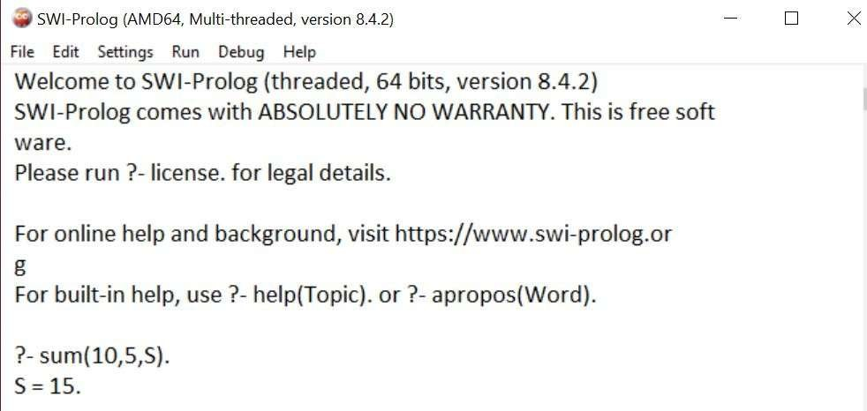

Program 2: Write a Prolog program to implement max(X, Y, M) so that M is the maximum of two numbers X and Y.

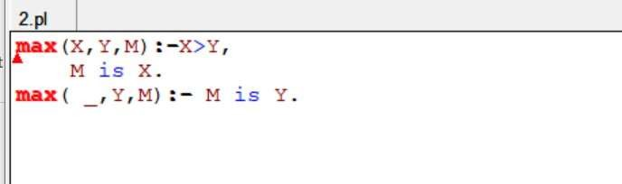

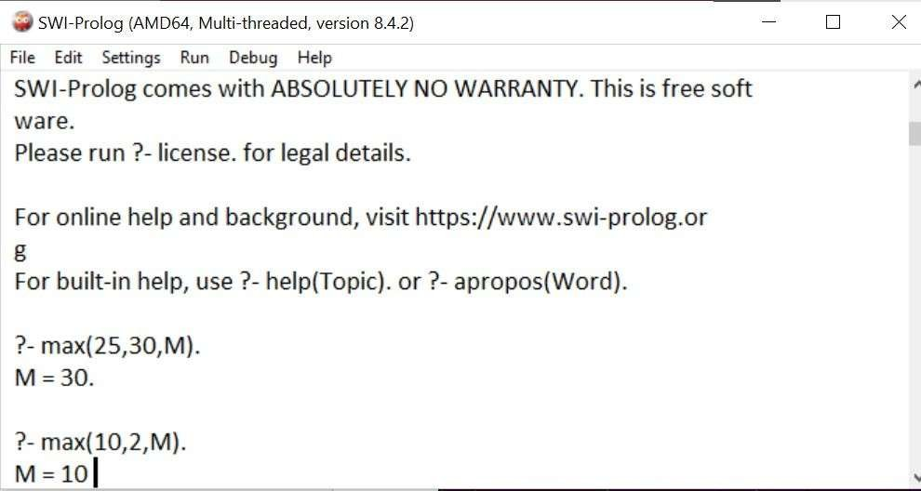

Program 3: Write a program in PROLOG to implement factorial (N, F) where F represents the factorial of a number N.

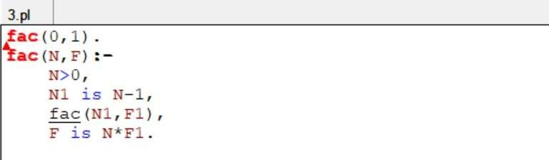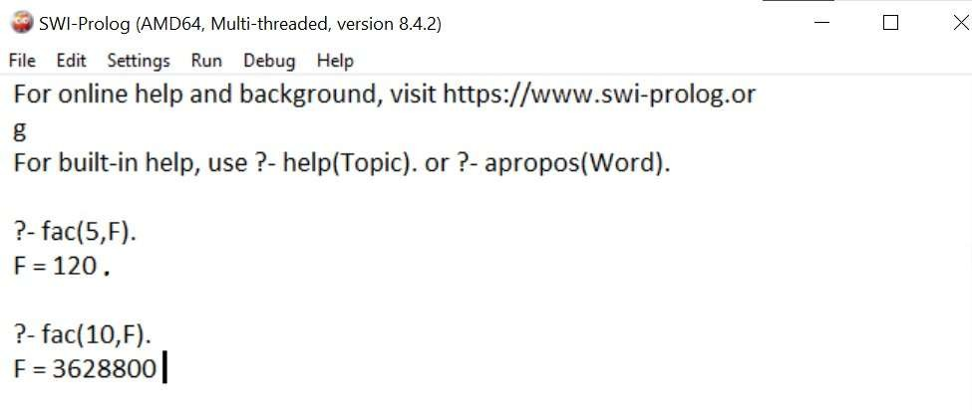

**Program 4: Write a program in PROLOG to implement generate_fib(N,T) where T represents the Nth term of the fibonacci series.**

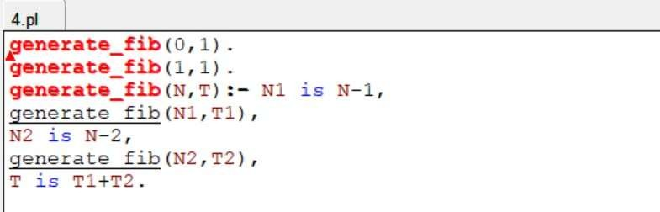

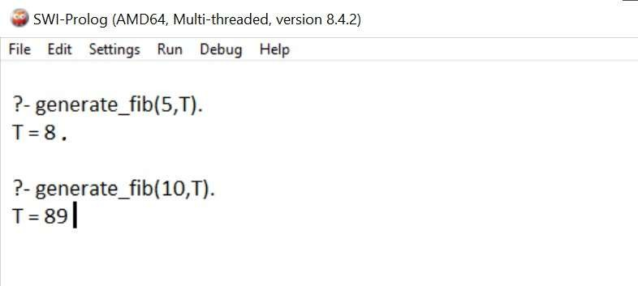

**Program 5: Write a Prolog program to implement GCD of two numbers.**

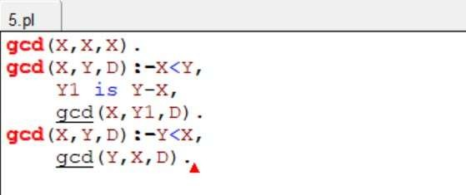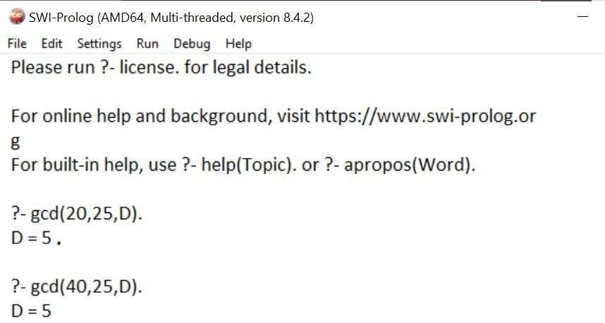

**Program 6: Write a Prolog program to implement power (Num,Pow, Ans) : where Num is raised to the power Pow to get Ans.**

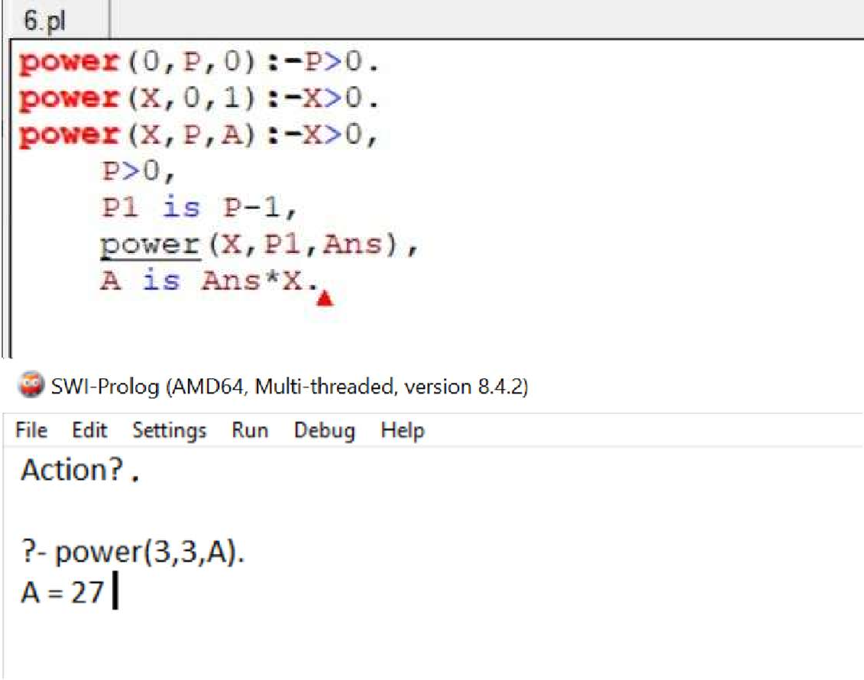

**Program 7: Prolog program to implement multi (N1, N2, R) : where N1 and N2 denotes the numbers to be multiplied and R represents the result.**

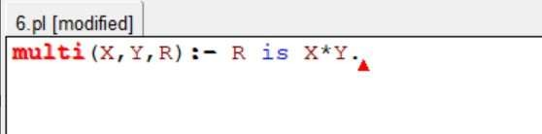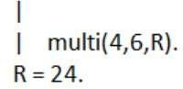

Question 8: Write a Prolog program to implement memb(X,L) : to check whether X is a member of L or not.

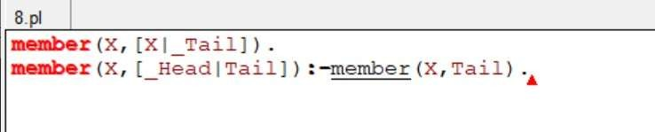

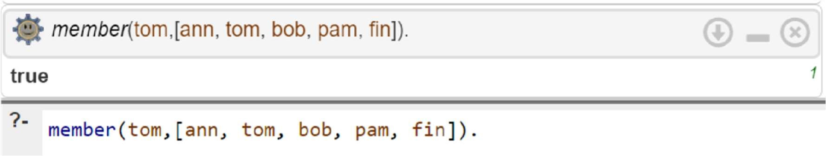

Question 9:- Write a Prolog program to implement conc(L1,L2,L3) where L2 is the list to be appended with L1 to get the resulted list L3.

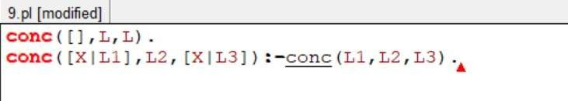

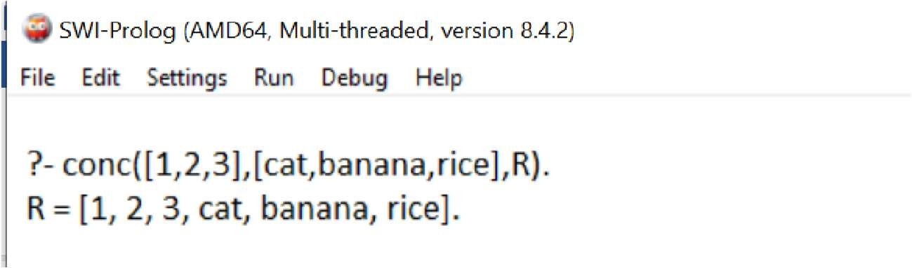

Question 10:- Write a Prolog program to implement reverse(L,R) where List L is original and List R is reversed list.

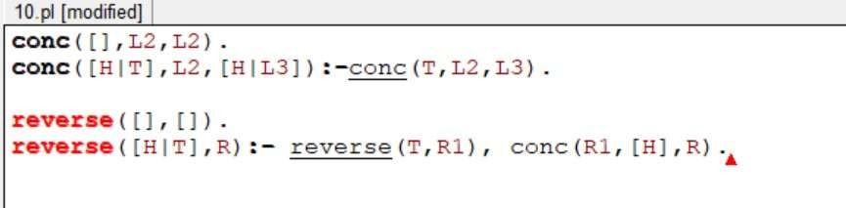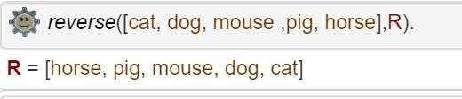

Question 11:- Write a program in PROLOG to implement palindrome(L) which checks whether a list L is palindrome or not.

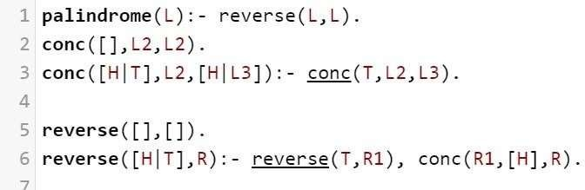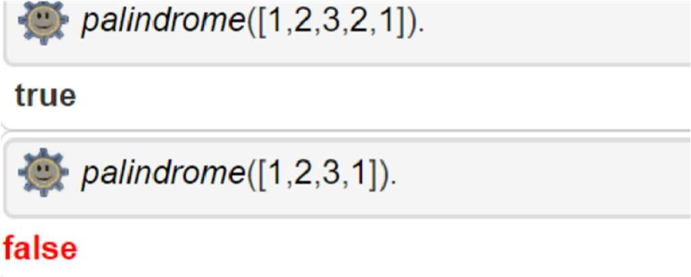

Question 12:- Write a Prolog program to implement sumlist(L,S) so that S is the sum of a given list L.

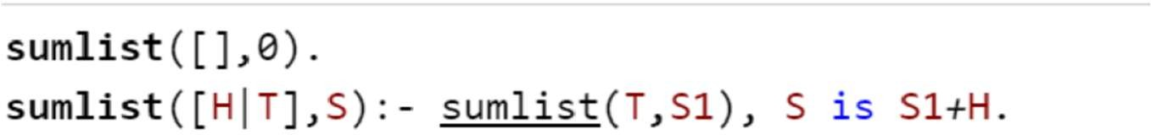

Question 13:- Write a Prolog program to implement two predicates evenlength(List) and oddLength(List) so that they are true if their argument is a list of even or odd length respectively.

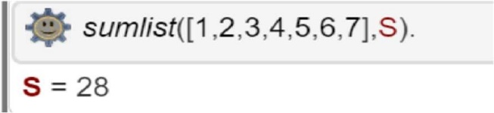

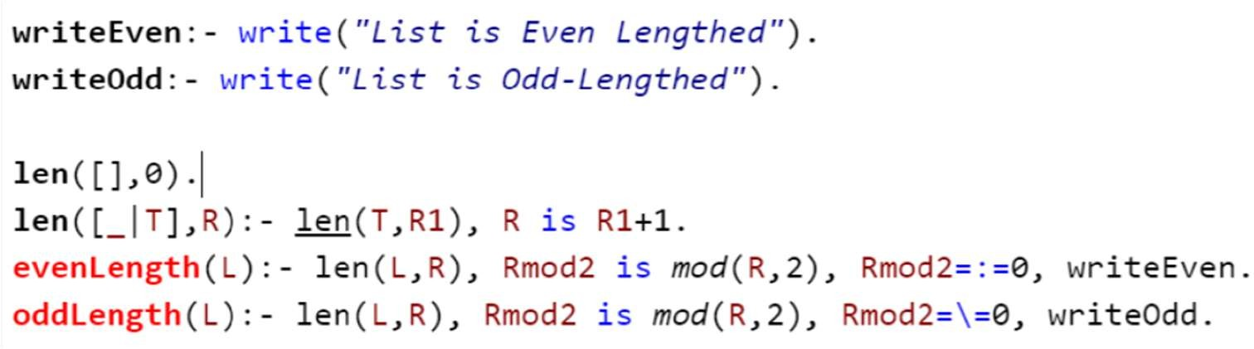

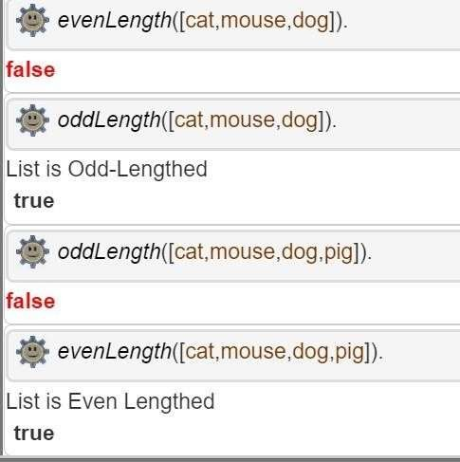

Question 14:- Write a Prolog program to implement nth_element(N,L,X) where N is the desired position, L is a list and X represents the Nth element of L.

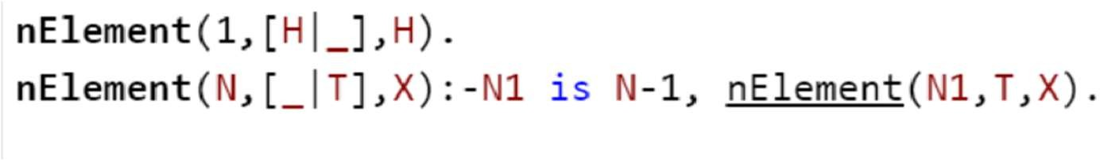

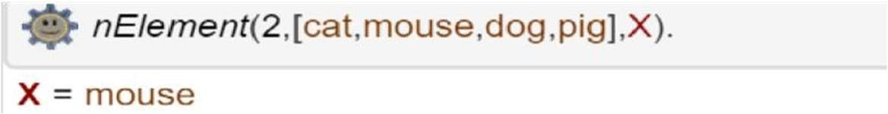

Question 15: Write a Prolog program to implement maxlist(L,M) so that M is the maximum number in the list.

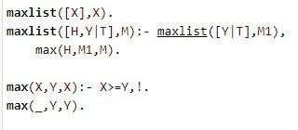

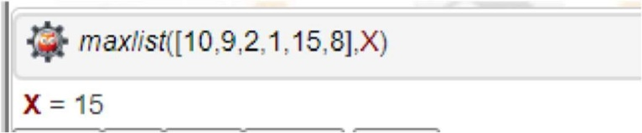

Question 16: Write a prolog program to implement insert_nth(I,N,L,R) that inserts an item I into Nth position of list L to generate a list R.

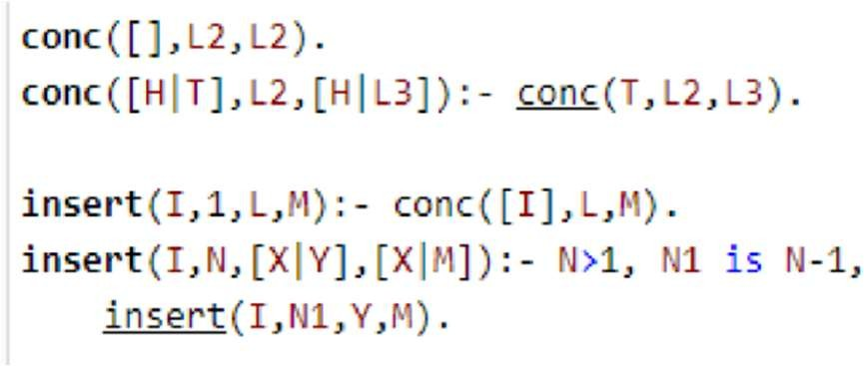

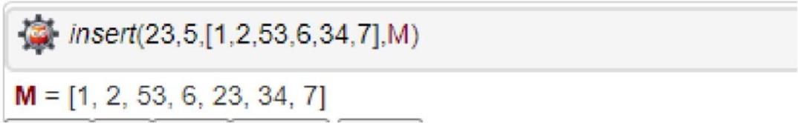

Question 17: Write a Prolog program to implement delete_nth(N,L,R) that removes the element on Nth position from a list L to generate a list R.

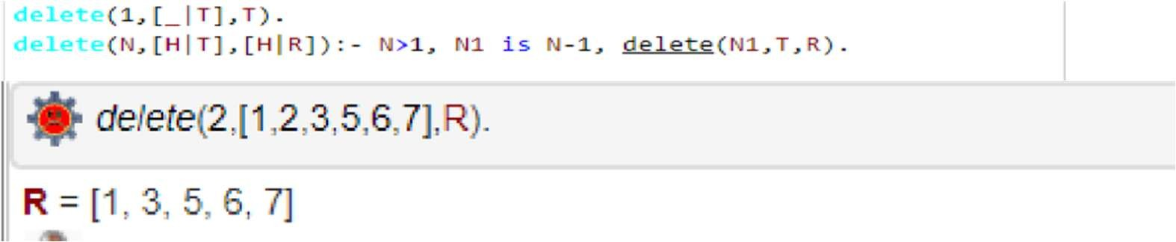

Question 18: Write a program in PROLOG to implement merge(L1, L2, L3) where L1 is first ordered list and L2 is second ordered list and L3 represents the merged list.

